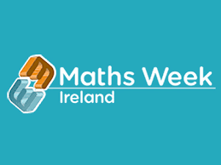

**Maths Week Ireland**

**14th – 18th October 2024**

This week we will participate in Maths Week Ireland. In school we will focus on practical maths, along with mental maths and problem-solving activities. We encourage you to focus on some practical maths at home as well. The link below will take you the Parents Zone on the Maths Ireland website. It has lots of ideas for maths activities that you can carry out at home and ideas for maths in everyday household tasks or you could play some games at home such as Snakes and Ladders, Monopoly, Connect Four, Ludo, Snap or Hopscotch. Alternatively, you could use your maths eyes when out for a walk or a drive looking for shapes, patterns or numbers in The World Around Us.

You can send pictures of your maths at home activities to your class teacher via the school email account:

info@braidsideips.ballymena.ni.sch.uk

Teachers will give Dojos and other class rewards for activities completed at home.

Have a fun Maths Week!

Mrs K Bradley

Vice – Principal, Numeracy Co-ordinator

www.mathsweek.ie/2024/parents