Braidside ICT/Digital Technologies Team
Application Form

Braidside Vision Statement-
We aim to work together to support each child in reaching their personal and academic potential within a culture of mutual respect.

Braidside ICT Vision Statement-
Our vision is for all teachers and pupils to become confident users of ICT so that they can develop the skills, knowledge and understanding which enables them to use appropriate ICT resources and devices effectively as powerful tools for teaching and learning.

Braidside IPNS requires a new pupil-based focus group known as Braidside ICT TEAM each year. This year, class ________ has been nominated by Mrs Fulton, to put forward applications from those interested in being part of this team. Wishing you all the very best in the application and selection process!

Signed _________________ BIPNS ICT Co-ordinator
Signed _________________ BIPNS Principal

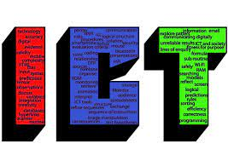
- Our school acronym for part of our e-safety is BIPNS. Posters were designed by a former ICT Team member. They are displayed around the school in close proximity to our ICT equipment.
Identify what each letter stands for and what the word is advising you to do.

B

I

P

N

S

- What is SMART an acronym for? Which area of online safety does it relate to?
________________________________________________________________________________________________________________

S M A R T

- Describe how you would ensure the safe use of electronic devices? What dangers are there and how would you prevent such electrical dangers?
________________________________________________________________________________________________________________________________________________________________________________________________________________________________________________________________________________________________________________________________________________
________________________________________________________________________________________________________________________________________________________________________

- What jobs/tasks would you be able to help with? Staff or pupils!
________________________________________________________________________________________________________________________________________________________________________________________________________________________________________________________________________________________
________________________________________________________________________________________________________________________________________________________________________

- Why should you be part of the team? What qualities and strengths do you have that would make you an effective ICT Team member/ ICT Manager? Please complete the box that follows…
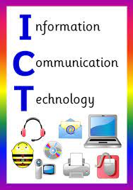

Thank you for applying for this Role of Responsibility.
All applications will be considered fairly.
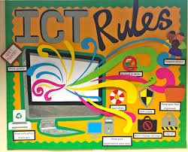
Maximum of 6 children will be chosen.

Thank you.

