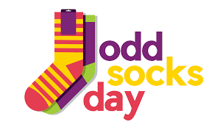
Anti-Bullying Week 2022

Dear Parents/ Carers,

This year, we are celebrating Odd Socks Day. Odd Socks Day is a chance for Primary schools to celebrate Anti-Bullying Week in a positive way by asking pupils to wear odd socks to school. Odd Socks Day is an opportunity to have fun, be yourself and spread awareness of the core values Anti-Bullying Week promotes. There is no pressure to wear the latest fashion or buy expensive costumes. All you have to do to take part is wear odd socks, it couldn’t be simpler!

Odd Socks day will take place on the first day of Anti-Bullying Week, Monday 14th November. The rest of your child’s school uniform should be worn as normal.

As a school, we will be participating in a range of Anti- Bullying activities throughout next week. We hope that the children will enjoy the week and find it valuable.

Yours sincerely,
Mrs K McLaughlin
