Friday, 11th March 2022
Hi boys, girls and parents.
Friday, 11th March is the start of British Science Week. British Science Week is a ten-day celebration of science, technology, engineering and maths that will take place between 11-20 March 2022! The theme for this year is ‘Growth’.
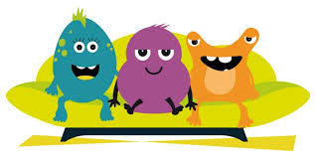
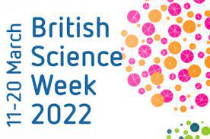

Getting involved in British Science Week is really easy, and you can take part in lots of different ways.
The staff of Braidside would like to mark British Science Week, beginning Monday, 14th March, with a week full of fun experiments for both the children and the adults to get involved in. There are so many simple science experiments that can be done at home using a variety of items that can be found in your cupboards, such as vinegar, baking powder, fizzy drinks, milk, shaving foam, washing up liquid!! The list is endless. You could try making jelly with your child. You could experiment with mixing different colours of jelly or with adding fruit. Don’t add fresh pineapple as this will stop the jelly from setting. You could be more adventurous and make ice-cream or make some yummy homemade bread. The children could find out about yeast and why it is needed for making bread.
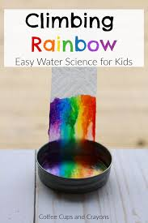
Next week, teachers will be incorporating fun science experiments into our classroom learning. We would also like the parents and children to get involved at home too! We don’t want to make this hard work for children and parents ….. we want to make it fun! We don’t want for parents to have to go out and buy items for the experiments instead we want you to use the items you already have in your cupboard.
To facilitate the practical science experiments at home, all the children from P1-P7 will have reduced homework. Some teachers might set an assignment with a specific experiment for you to try out. Other teachers might set assignments where you are free to choose the experiments you would like to try. Remember the idea behind the experiments is to have fun and to learn through investigating and exploring. A really good website to use for simple science ideas is
https://www.sciencefun.org/kidzone/experiments/
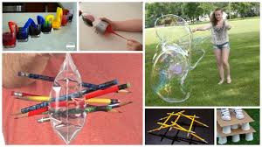
We would love to post photos onto the school website showing your children carrying out the experiments so if you could take some photo and send them to your class teacher that would be great.
We really hope that you have lots of fun trying out the different experiments and we look forward to hearing how you get on and seeing your wonderful photographs.
Mrs K McLaughlin and Miss Hart (TWAU coordinators)
