Friday, 5th March 2021
Hi boys, girls and parents.
I hope you enjoyed doing some of the lovely World Book Day activities this week. I was amazed at the wonderful work I’ve seen so far. There is so much creativity and great work being produced by the boys and girls at Braidside. You are all truly amazing.
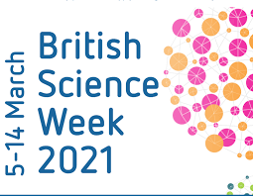
Friday, 5th March is the start of British Science Week. British Science Week is a ten-day celebration of science, technology, engineering and maths that will take place between 5-14 March 2021!

Getting involved in British Science Week is really easy, and you can take part in lots of different ways.
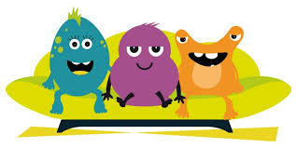

The staff of Braidside would like to mark British Science Week, beginning Monday, 8th March, with a week full of fun experiments for both the children and the adults to get involved in. There are so many simple science experiments that can be done at home using a variety of items that can be found in your cupboards, such as vinegar, baking powder, fizzy drinks, milk, shaving foam, washing up liquid!! The list is endless. You could try making jelly with your child. You could experiment with mixing different colours of jelly or with adding fruit. Don’t add fresh pineapple as this will stop the jelly from setting. You could be more adventurous and make ice-cream or make some yummy homemade bread. The children could find out about yeast and why it is needed for making bread.
What is yeast? Yeast is a live, single-celled fungus. Active dry yeast lies dormant (despite the name) until it comes into contact with warm water. Once reactivated in warm water, yeast begins feeding on the sugars and releasing carbon dioxide. The carbon dioxide forms a layer of small bubbles on the water surface. This is called anaerobic fermentation. This is amazing science for the children to experiment with!!!
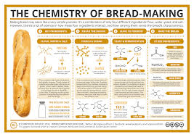

Next week, the teachers in P1-P3 will be doing different science experiments with their classes. For P4-P7, the teachers will be incorporating fun science experiments into our online home learning. We don’t want to make this hard work for children and parents ….. we want to make it fun! We don’t want for parents to have to go out and buy items for the experiments instead we want you to use the items you already have in your cupboard.
Some teachers might set an assignment with a specific experiment for you to try out. Others teachers might set assignments where you are free to choose the experiments you would like to try out. Remember the idea behind the experiments is to have fun and to learn through investigating and exploring.
As a school, we are going to post some ideas and examples for science experiments for you to try. The examples will explain the science behind the experiments. You do not have to do all the experiments …… just pick some that your child would like to try out. Also, you don’t have to use any of the examples posted as you might have other experiments that you would like to try out.
For Well Being Wednesday, we would love it if the whole family could get involved in one of the fun experiments.
We would love to post photos onto the school website showing your children carrying out the experiments so if you could take some photo and send them to your class teacher that would be great.
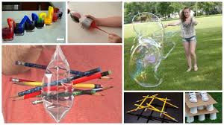
I really hope that you have lots of fun trying out the different experiments and I look forward to hearing how you get on and seeing your wonderful photographs.
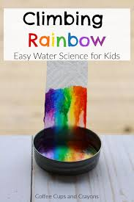
Have fun
From
Mrs K McLaughlin and Miss Hart
(TWAU coordinators)
