Creative Writing – 4th February
Jamie Goligher

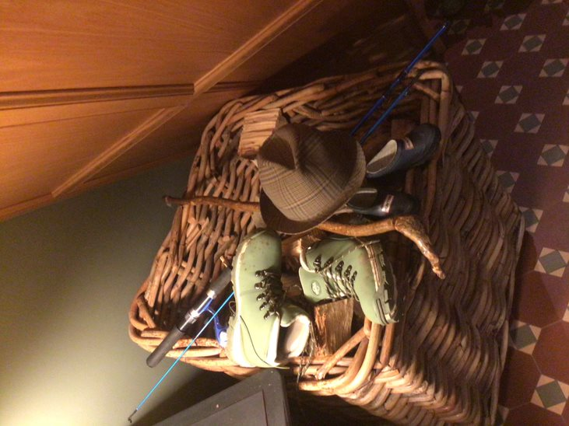

An old man called Eamon who wore a brown hat, green boots and had a walking stick took his granddaughter on a fishing trip to Altnahinch Dam. Eamon’s granddaughter is called Bella, she has long curly blonde hair and on the trip she wore black hunter shoes. Eamon and Bella were both very excited because it was Bella’s first time fishing. It was a sunny Saturday morning in March but it was as cold as ice. They were lucky and caught a big salmon for their dinner and Eamon said “why can’t it always be this easy to catch a fish?” They had a great day fishing but couldn’t wait to get home and kick off their shoes and get some logs on the fire.

