The Eruption
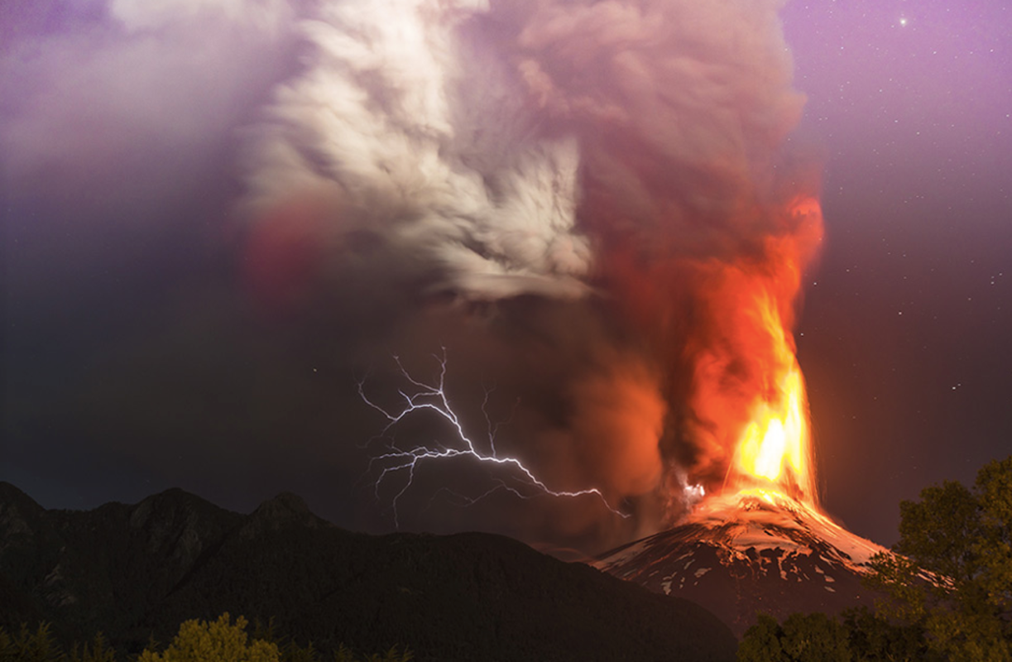
It was one of the worst eruptions yet! It was a tornado of lava, ashes and smoke. Nature had turned on us. Lightning, thunder, lava and ash were swirling around us, trapping us. I saw the luscious, green grass turning coal black, the tropical palm trees fell and reached the same fate. It was dark to add to everything else.
Even the aged apple trees had fallen. Oh no! The 102-year-old oak tree, the centrepiece, the pride of the village on the outskirts of the country was being tortured but still standing strong... for now! People were screaming and we were being pushed closer and closer to each other as the smoke, ash and red-hot lava were closing in.
I shut my eyes, hoping I could make it go away, but when I opened them, we were still in the tornado of the eruption. There was a blinding flash of lightning and out of the corner of my eye the old oak finally give in to the malicious attack of the worst eruption of the decade. It fell in slow motion, and then it was gone in a blink! The storm closed in harder and people around me started to fall. My eyes were heavy, it felt hard to breathe.
Suddenly I wake in a white van travelling at high speed, surrounded by others. Where are we and where are they taking us?

