



**Important Upcoming dates for your Diary**

**Work and play at home month!**

**Happy Healthy Me Launch (details to follow)**

**Marvellous Me Cuddly Toy Animal Party (details to follow)**





***Happy Birthday this month to:***

**Daniel**

**JANUARY IN THE NURSERY**



C:\Users\John\AppData\Local\Microsoft\Windows\Temporary Internet Files\Content.IE5\BB58NA7J\MC900280935[1].wmf C:\Users\John\AppData\Local\Microsoft\Windows\Temporary Internet Files\Content.IE5\RO1F8W0U\MC900022810[1].wmf C:\Users\John\AppData\Local\Microsoft\Windows\Temporary Internet Files\Content.IE5\7VK9GAV6\MC900281095[1].wmf 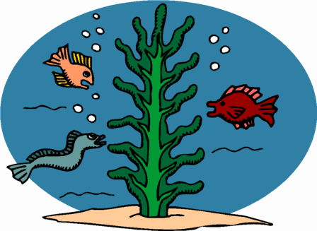

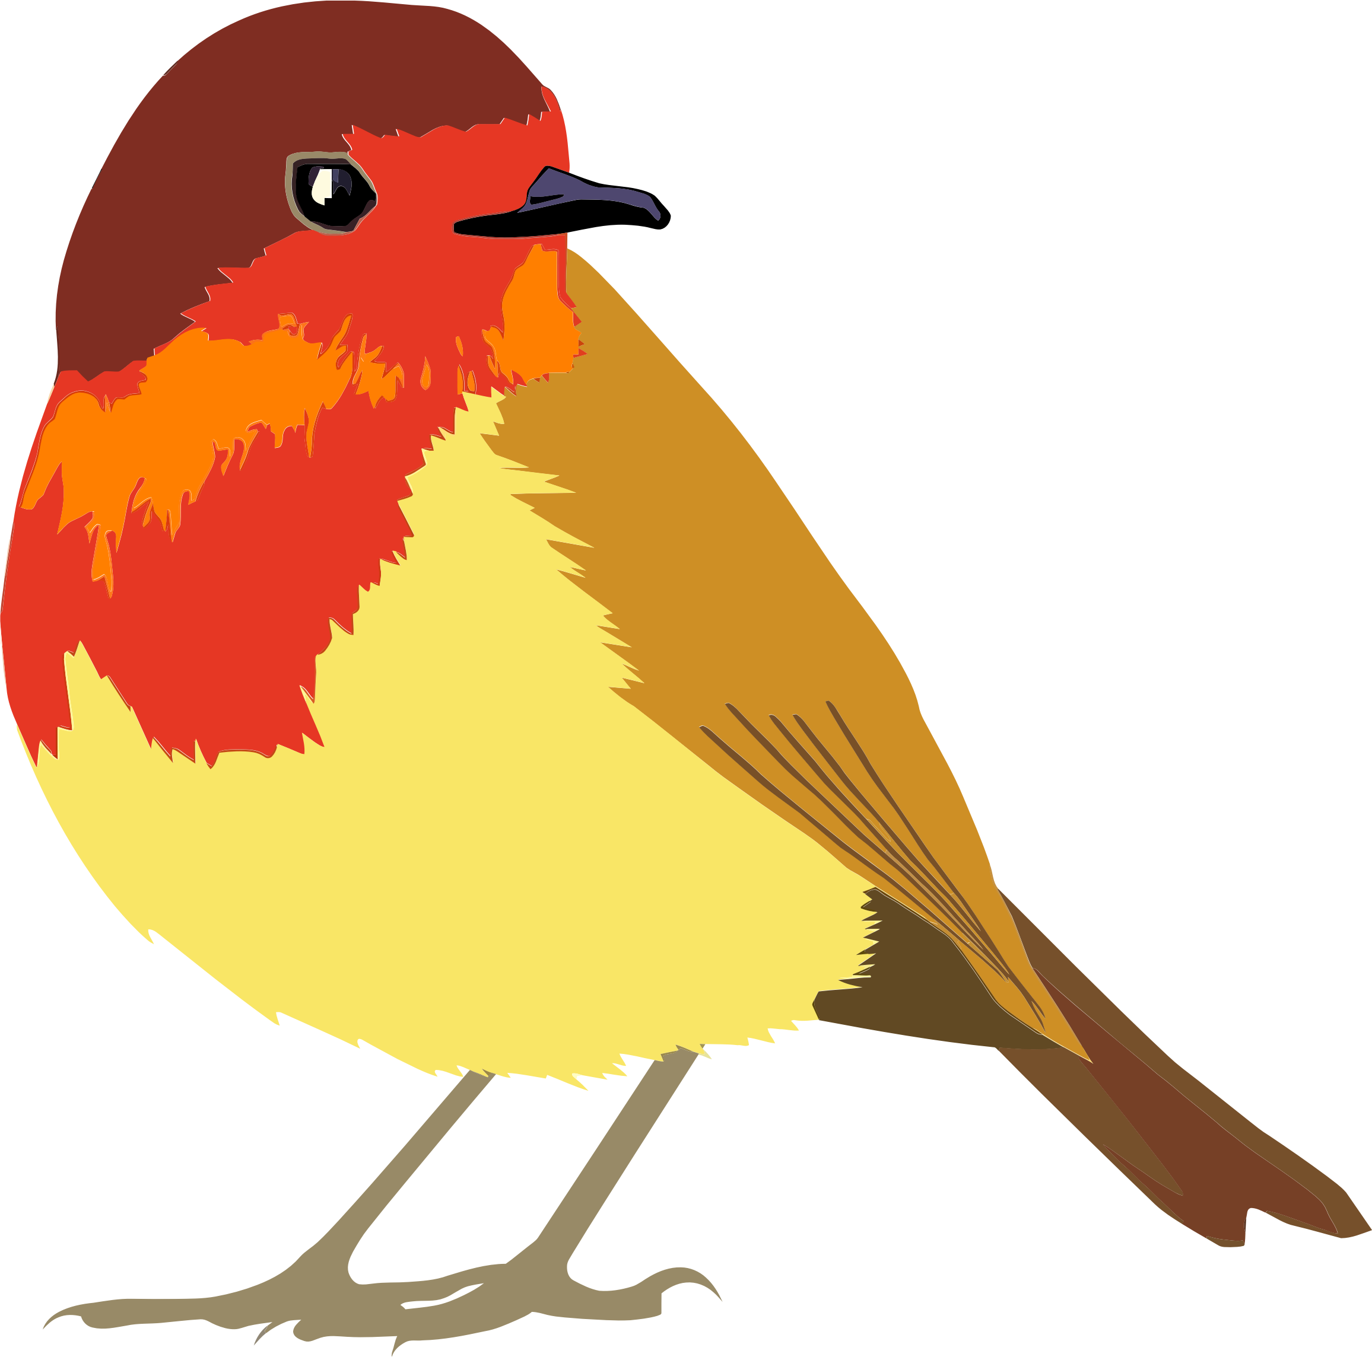 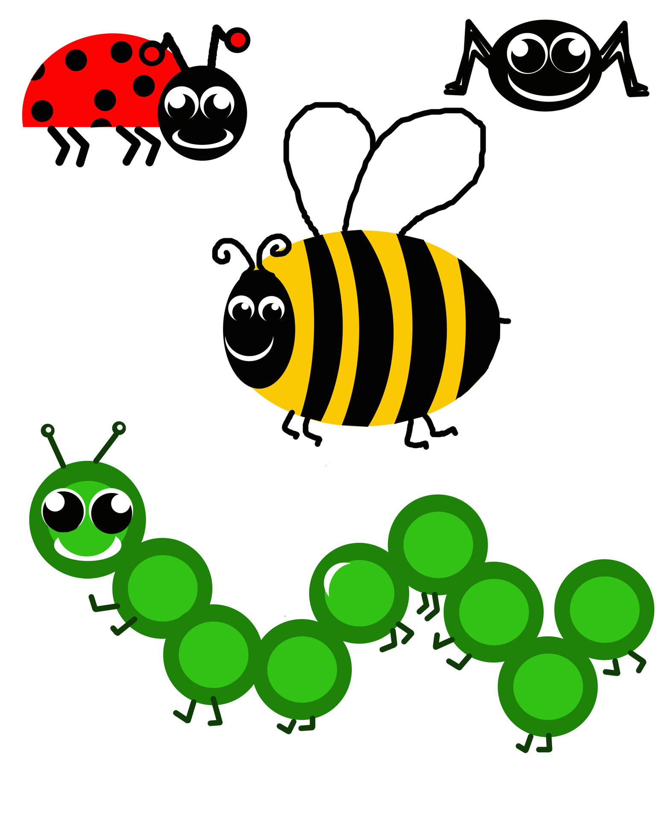  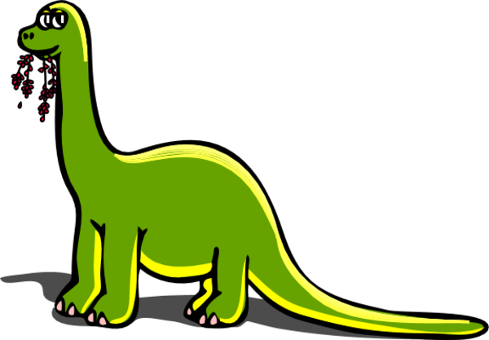

**Our theme this month is ‘All Creatures Great and Small’**

**Over the next few weeks, we will be learning all about different animals - polar, farm, pet, wild, in the air, on the ground, under the water, and from long ago! To help us with our learning, please gather up a few ‘junk’ items - a small empty box (eg. tissue), a kitchen roll tube, or an egg box. Also look out for an announcement about our Marvellous Me Animal Party when you can let your child dress up as an animal for a morning! As I say, further details will follow on Seesaw in due course!**

 +  = 

**Our colours this month are black, white and grey.**



**The shape we are learning about is a triangle.**

**We will be singing songs about the numbers 1-5, and talking about the number 6.**

**The concept we will think about is length - long and short; and also comparing language (eg. fast, faster, fastest; loud, louder, loudest; tall, taller, tallest; etc)**





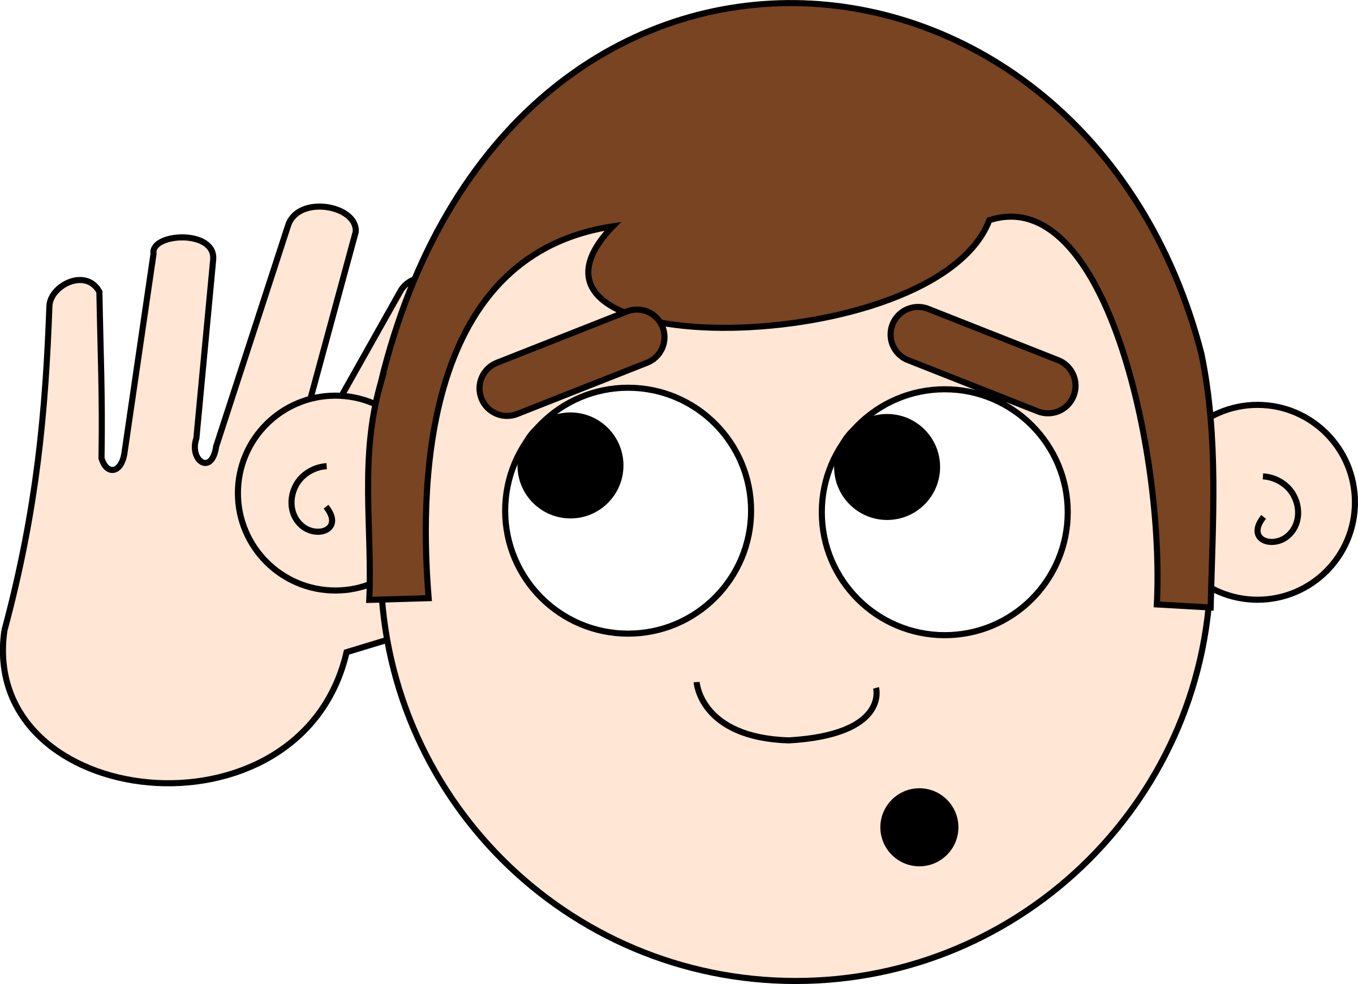

**Our Personal Development focus this month is to have kind ears that do good listening.**

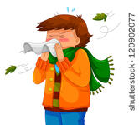

**Our independence target is to try and blow our own nose.**



**Our Physical Development targets are to develop our body movement strength by copying copying different animal movements; and to develop our pointing finger strength.**

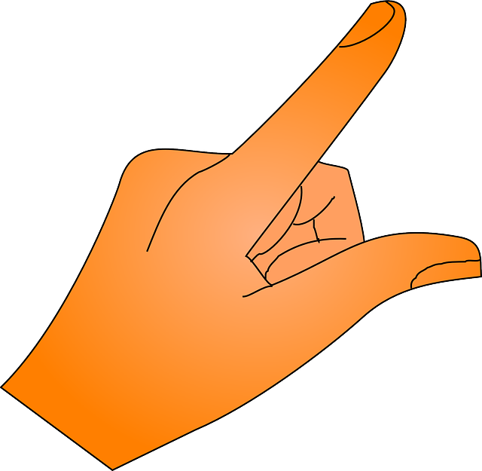

**Other relevant information is included along with the nursery rhymes and songs we are learning which are written out on the back page so you can practise them at home!**

1. Can you name these animals?

2. Do you know where they live? (farm, jungle, grassland, sea, cold

lands, forest, field, stable, kennel, cage, nest, on the ground)?

3. What noises do they make?

4. What are their babies called? (pup, kitten, chick, cub, calf, foal,

lamb, piglet, egg)

5. Can you name different body parts? (tail, paws, trunk, whiskers)

|  |  |  |  |
| --- | --- | --- | --- |
| polar bear  MC900229081[1] | penguin  MC900332390[1] | shark  shark by OlKu - shark in water | crocodile  MC900192165[1] |
| cat  dglxasset[1] | dog  MC900128719[1] | rabbit  MC900013227[1] | horse  MC900235199[1] |
| sheep  dglxasset[1] | pig  MC900326472[1] | MC900036353[1]cow | MC900197880[1]chicken |
| lion  dglxasset[1] | MC900091101[1]monkey | MC900029948[1]elephant | MC900324470[1]snake |
| bird  Bird-Looking-Over-Its-Shoulder | squirrel  Squirrel | Spiderspider | large-dinosaur-holding-plants-in-his-mouth-66dinosaur |

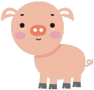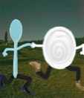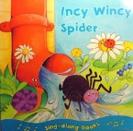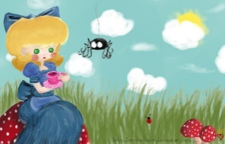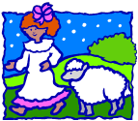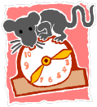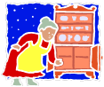MC900138275[1]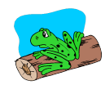MC900390914[1]