

**in**





**Important Upcoming dates for your Diary**

**Anti-Bullying Week 16th-20th November**

**Big Bedtime Read Launch & PJs Movie Night on Fri 4th Dec**

**Nursery Rhyme Dress-Up Day on Wed 9th Dec**





***Happy Birthday this month to:***

**Big Ted !**

**NOVEMBER IN THE NURSERY**



**Our theme this month is ‘Rhythm and Rhyme’**

**Nursery rhymes play a very important role in our children’s early lives, particularly when it comes to the development of crucial language and communication skills. It is also World Nursery Rhyme week during this month, so over the next few weeks, we will be learning lots of Nursery Rhymes! We have set the children a challenge to try and learn five rhymes over this half-term, at the end of which they will receive a prize! In order to help with this, please encourage your children to recite nursery rhymes to you as often as possible! To help you, a list of the rhymes we have been learning or will be learning over the year is included overleaf with special focus being given to the first eight. Or why not let them make up their own?!**

MC900390834[1]



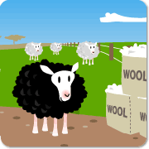





**During song/rhyme time we will also be introducing the children through music to the idea of rhythm and beat (which has been shown to be important in the development of both reading and more highly controlled movement skills). To help in this topic, please encourage your children to sing, dance, listen to music and make music as much and as often as possible!**



**You could even help them create a shaker instrument for making their own music and rhythms by filling an empty round-sided tube (empty Pringle tubes are ideal!) with something noisy like rice or pasta. Why not experiment with what you put inside to see what different noises you can make? Always remember to secure the lid on though!**

**Finally, we will be exploring some familiar nursery stories with the children at story-time, in particular focusing on the repeated ‘chant’ which occurs in many of them (eg.“I’ll huff and I’ll puff and I’ll blow your house down!” or “Run, run as fast as you can – you can’t catch me, I’m the gingerbread man!” or “Who’s that trip-trapping over my bridge?!”). A list of those we will be looking at is included overleaf if you wish to read them at home.**

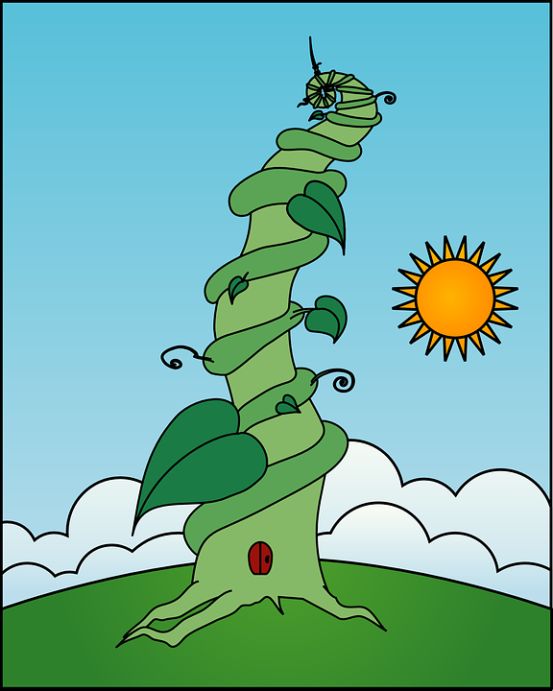



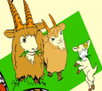







**Our colour this month is yellow.**





**The shapes we are learning are rectangle and diamond.**

**We will be talking about the numbers 1 - 3.**

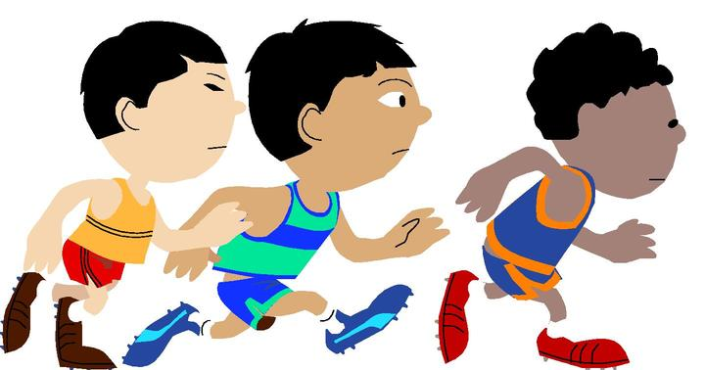

**The concept we will be thinking about is order - first, next, last.**

 

**Our Personal Development focus this month is ‘Busy Hands’. We will always try to have hands that are busy at play, and that help tidy up.**

**Our independence target is being able to take off and put on our own shoes and wellie boots. Please practise this with your child at home.**



**Our Physical Development targets are to develop our hand strength, our balance, and to move creatively to music.**



**Other relevant information is included - please read at your leisure.**



**Rhymes Stories**

**1. Humpty Dumpty 1. Goldilocks and the Three Bears**

**2. Jack and Jill 2. The Three Little Pigs**

**3. Two Little Dickey Birds 3. The Three Billy Goats Gruff**

**4. Hickory Dickory Dock 4. The Little Red Hen**

**5. Incy Wincy Spider 5. The Gingerbread Man**

**6. Little Miss Muffet 6. Jack and the Beanstalk**

**7. Twinkle, Twinkle, Little Star 7. Chicken Licken**

**8. Baa, Baa, Black Sheep 8. Little Red Riding Hood**

**9. Little Bo Peep 9. The Enormous Turnip**

**10. Little Boy Blue 10. The Elves and the Shoemaker**

**11. This Little Piggy**

MC900116044[1]**12. Hey Diddle Diddle**

**13. The North Wind Does Blow**

**14. Mary, Mary, Quite Contrary**

**15. Little Jack Horner**

**16. Row, Row, Row Your Boat**

**17. 1,2,3,4,5, Once I Caught a Fish Alive**

**18. Miss Polly Had a Dolly**

**19. Polly Put the Kettle On**

**20. I’m a Little Teapot**

MC900116092[1]**21. Round and Round the Garden**

**22. The Grand Old Duke of York**

**23. Ring-a-ring o’ Roses**

**24. Rock-a-bye Baby**

**25. Doctor Foster**

**26. Sing a Song of Sixpence**

**27. Wee Willie Winkie**

**28. Rock-a-bye Baby**

**29. Pat-a-cake, Pat-a-cake, Baker’s Man**

**30. Old Mother Hubbard**

**31. The Queen of Hearts**

**32. One Potato, Two Potato**