

**in**





**Important Upcoming dates for your Diary**

**Marvellous Me Mondays - note of explanation to follow on Seesaw**

**Table-top Tuesdays - note of explanation to follow on Seesaw**

**Maths Week from 10-18 October**

**Settling-in Interviews - to be arranged by phonecall**

**Hallowe’en Dress-up Day - Friday, 23rd October**

**Half-term: last day-Fri 23rd Oct, first day back-Mon 2nd Nov**

***Happy Birthday this month to:***

**Sadie and Henry**





**OCTOBER IN THE NURSERY**





**Our theme this month is ‘Out and About’**

**To help us with part of our learning in this topic, could you please go for a walk with your child and talk about what you see, hear, smell. Please send in some autumny things that you find (eg. leaf, cone, seeds, piece of autumn fruit/veg eg. carrot, potato, apple). Thanks!**

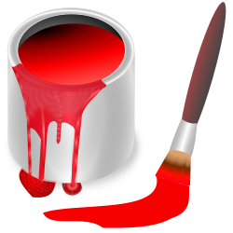

**Our colour this month is red, for autumn leaves.**

 

**The shapes we are learning about is a square and a leaf.**

**We will be talking about the number 3.**

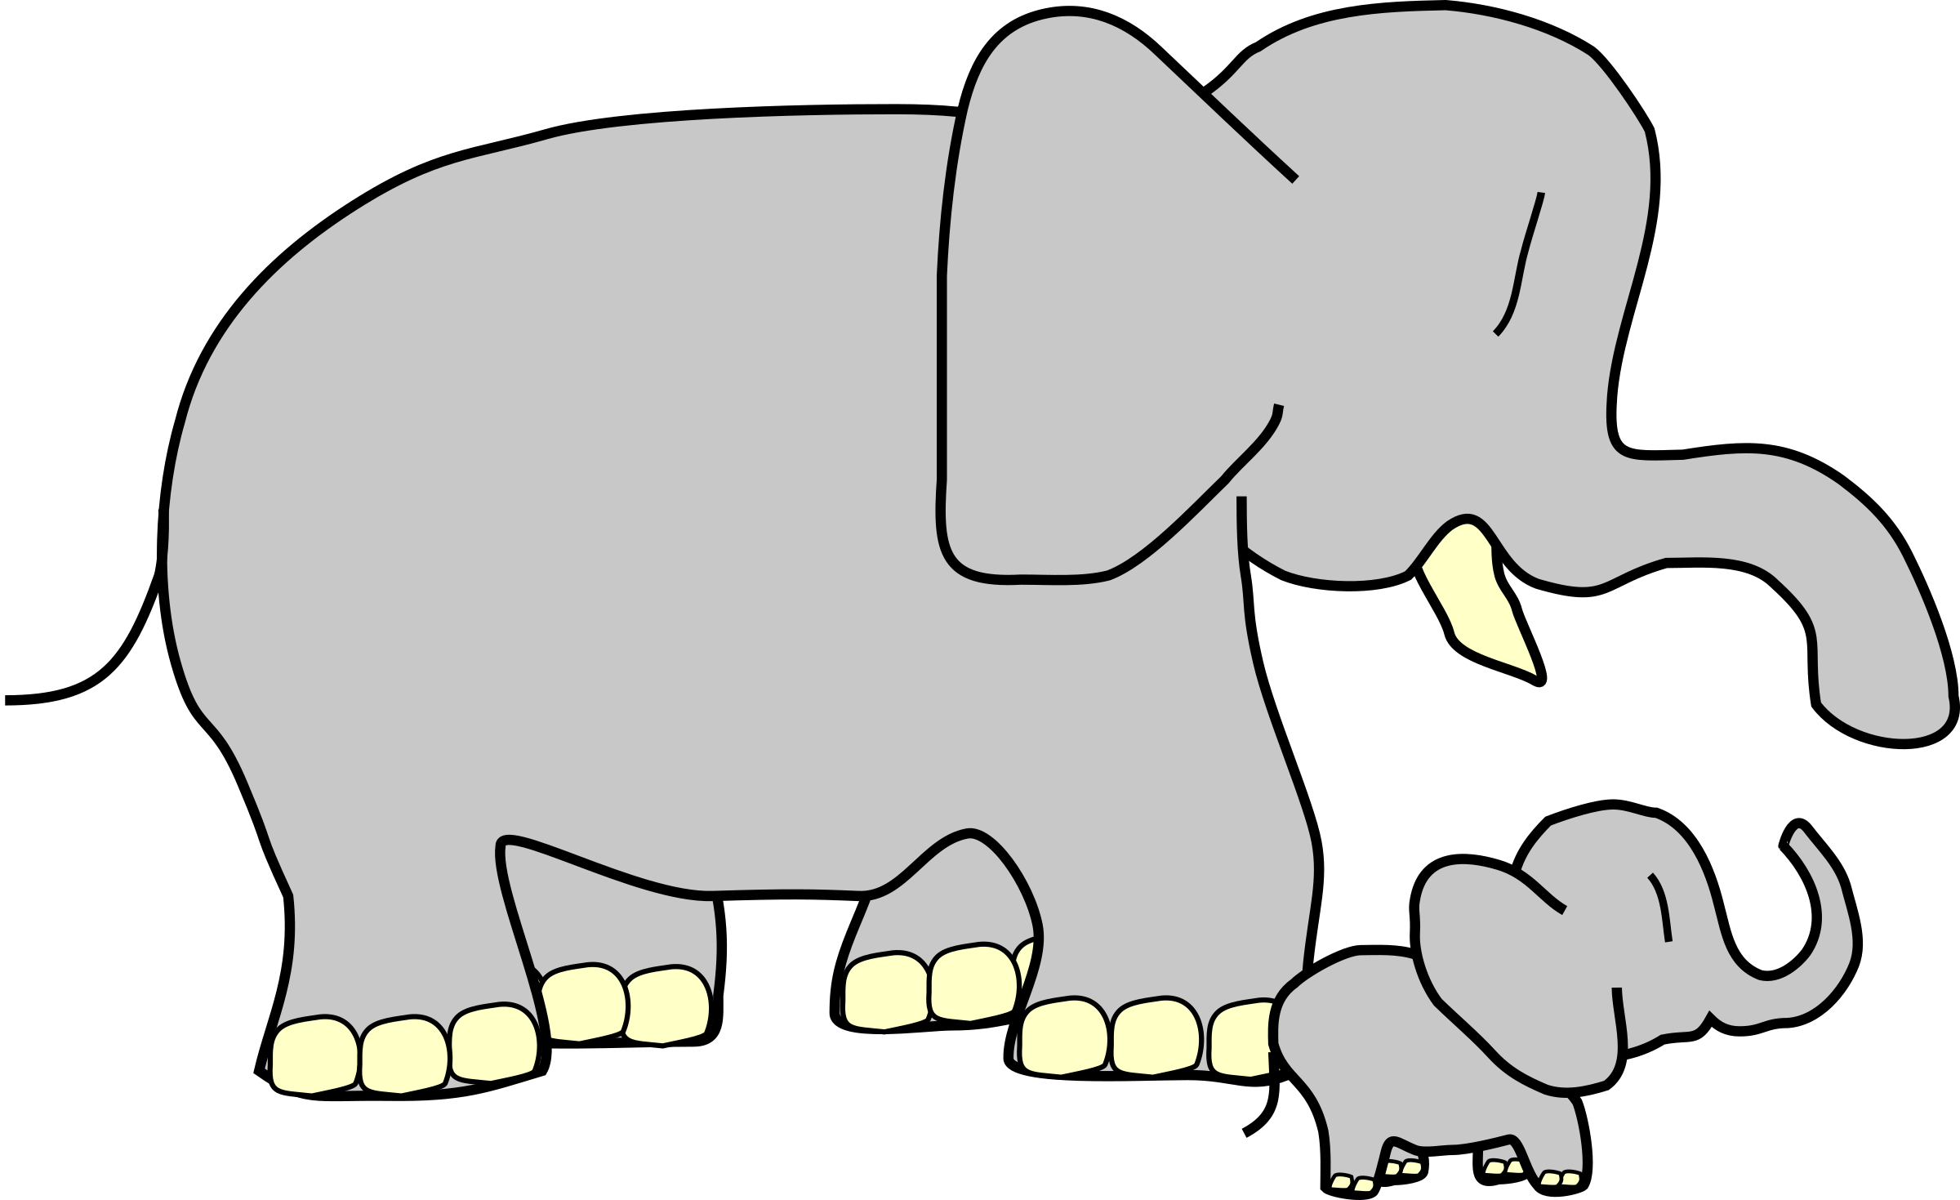

**The concept we will be thinking about is size - big and small.**

**Our Personal Development focus this month is sharing. We will talk about being kind and giving the other children a turn with the toys.**

**Our independence target is to be able to do our toilet routine on our own - fixing our clothes, wiping, and remember hand washing.**

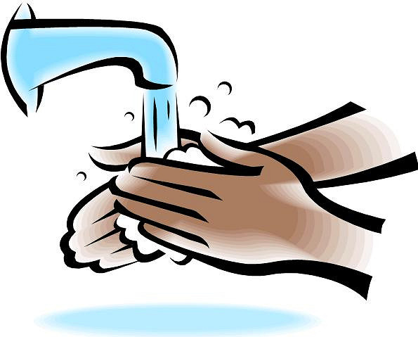

**Our Physical development focuses are to play outside in the dirt, and to develop our hand and finger strength (eg. grabbing, squeezing).**

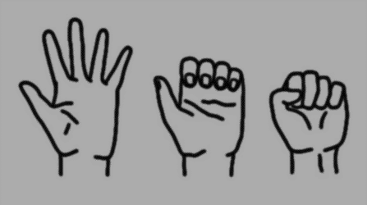

**Our nursery rhymes and songs we are learning are written out for you on the back page, so you can have fun practising at home!**

**Other relevant information is included - please read at your leisure.**

MC900300203[1]**Can you name some things on an autumn tree?**

**—–— leaves**

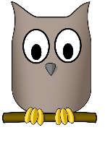

**twigs ——————**

**—–- owl**

**--—– branches**

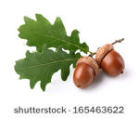

**acorns ————**

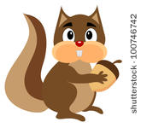

**—– squirrel**

**trunk ———–--**

MC900122859[1]

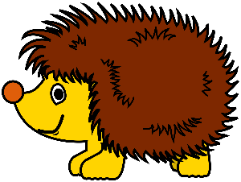

**—–— hedgehog**

**conkers ———**

What colours are the autumn leaves? (eg. yellow, red, orange, brown)

What animals come out more in the autumn time? (eg. squirrels, hedgehogs, owls, foxes)

What is the weather like (eg. cold, windy, wet, dark)

What clothes do we wear? (eg. coats, wellies)

