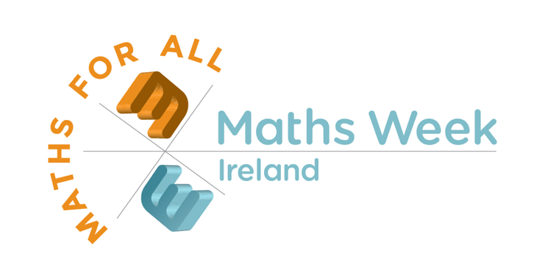
This week we will take part in Maths Week Ireland (10th – 18th October). We will have lots of class based fun maths activities for the children to complete in class. As well as this we would like the children to use their “maths eyes” at home.
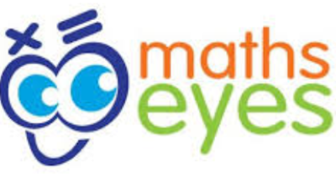
- Put on your “maths eyes” and look in a new way at your surroundings. Simply look around your house, out in your garden, out for a walk or on your way to school for examples of maths; look for numbers or shapes, angles, colours; anything at all.
- Take a digital photograph
- Choose your best photo and think of an appropriate title for it. Upload your image to Seesaw (P1 and P2 classes), TEAMS (P3 to P7) or if it is easier you can email your picture to the school info account ( info@braidsideintegratedps.ballymena.ni.sch.uk) or directly to the class teacher if you have their email.
- Closing date for pictures: Monday 19th October 2020.
- There will be some prizes for the most creative pictures.
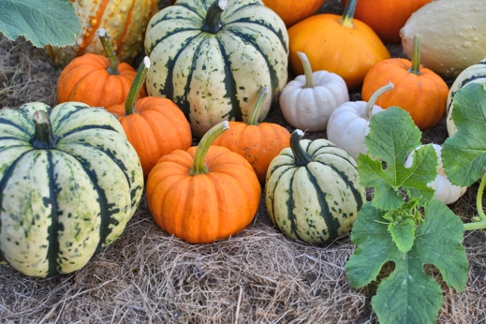
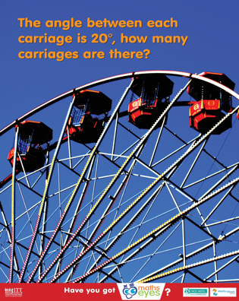
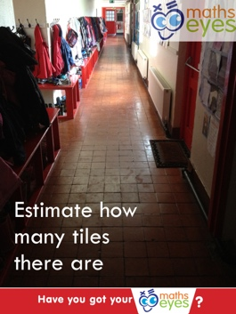
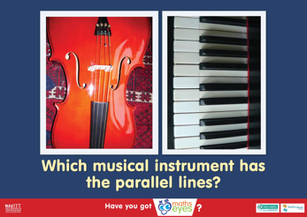
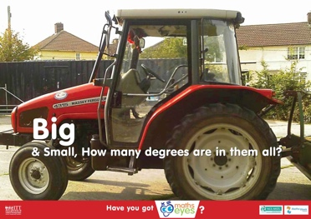
Some examples:
Spheres

