Braidside Integrated Primary

and Nursery School
87 Frys Road, Ballymena Co. Antrim BT43 7EN
1989- 2019: 30 Years of Integration

028 25647899 Principal: J McAuley
www.braidside.co.uk
03/07/20

ONLINE SUPPORT FOR CHILDREN ENTERING YEAR 7

Dear Parent,
The Department of Education (DE) has proposed a scheme whereby all current Year 6 children and their parents may access online learning programmes in English and maths.
Children will require access to a tablet, laptop or smart phone to access the programmes. Parental engagement is optional.
There are many online support materials however one such commercial programme that could be used is MathematicsMastery; which contains both literacy and numeracy.

As with the use of any online programme or application it will be important that parents consider both appropriate levels of screen time and their child’s online safety. Parents may find the EA online safety guidance useful:

https://ineqe.com/safeguarding-hub/
https://www.saferinternet.org.uk/advice-centre/parents-and-carers

In addition, the “Supporting Learning” material available on the EA website and specifically EA designed material, link directly with NI Curriculum, provides reinforcement and a reminder of the key literacy and numeracy concepts across Key Stage 2.

Mathematics Mastery
Mathematics Mastery provides a structured programme for literacy and numeracy and step by step guides for parenst.
Parental access to the programme is straightforward, there is no need to register just access the “Free Covid-19 Resources” at the top of the Mathematics mastery homepage:
https://www.mathesmaticsmastery.org./

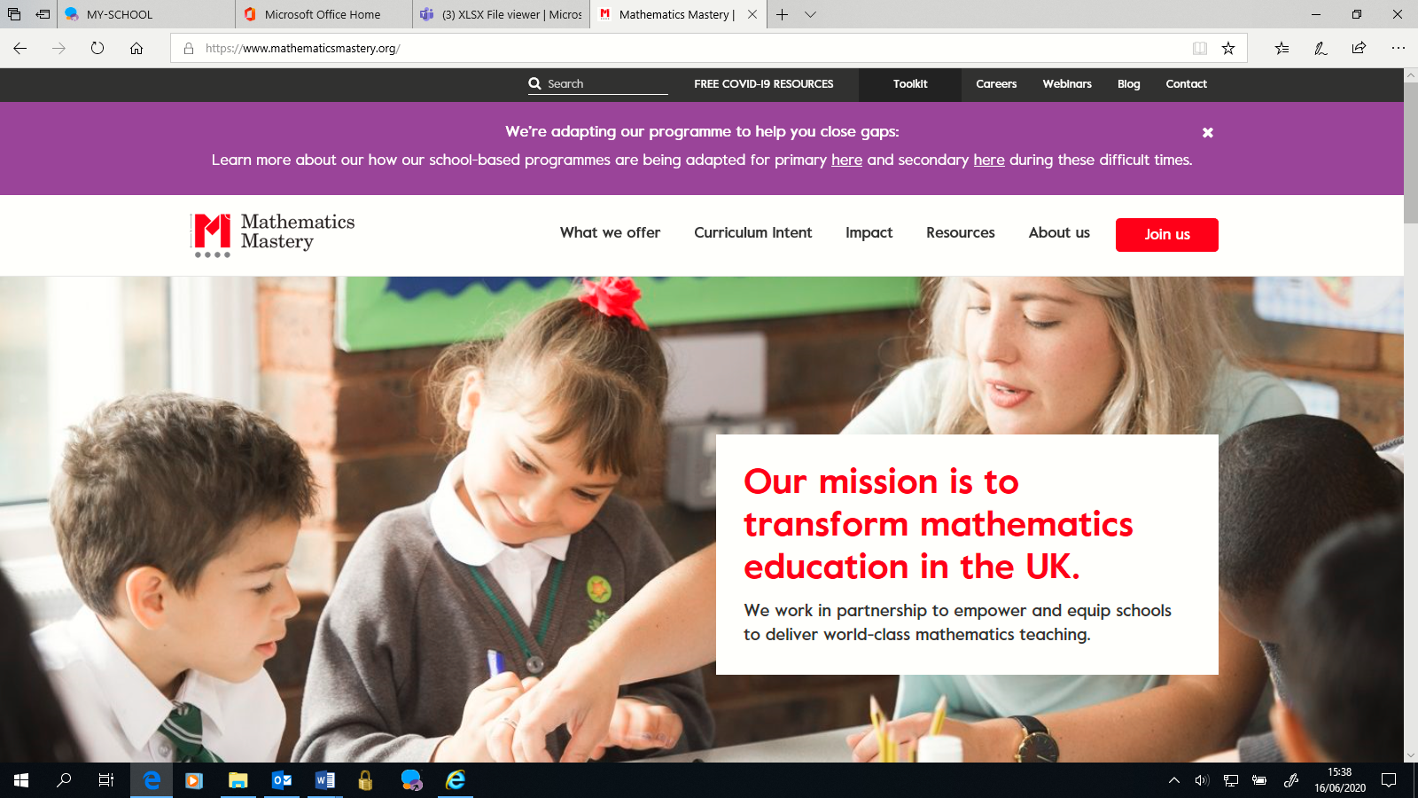

There are two maths packs for each year group, one has the guidance pages and the other the pupil facing resources. Parents need to access both packs as the pupils’ packs do not make sense without the guidance. To reduce printing, the guidance packs can be accessed digitally as they contain embedded video links.
There are also two literacy packs with the guidance included.

Year 5 [approximately equivalent to year 6 in NI] printable packs
- Maths Year 5 Weeks 1-4 Guidance pack (easy for parents/guardians to guide learning)
- Maths Year 5 Weeks 1-4 Pupil pack
- Maths Year 5 Weeks 5-9 Guidance pack (easy for parents/guardians to guide learning)
- Maths Year 5 Week 5-9 Pupil pack
- English Year 5 Workbook (week 1-4) (guidance included)
- English Year 5 Workbook (week 5-9) (guidance included)

