P4/5M – Week 8 (Term 3)
Week beginning Monday, 8th June 2020
Hi P4/5M
How are you? I hope you all are keeping safe and keeping healthy. I’m still missing all of you. The weather has been very changeable recently. One day we are having glorious sunshine and the next day it is cold, wet and windy. However, I don’t think we can complain as the weather has been so good during lockdown and it has definitely made lockdown more bearable for me. How are you all getting on with school work. This week Ben and Harry managed to get all their work finished by Thursday so they had the whole Friday off. The idea of getting a Friday off is definitely keeping them more motivated. The 8th June is World Ocean Day so I’ve uploaded some work on oceans for this week.
Below is a guide for you to use this week. Remember that it is only a guide, and I wouldn’t expect you to cover everything on this list. Just do as much as you can.

Weekly Fact – Measure Facts
10mm = 1cm
100 cm = 1 metre
1000 metres = 1 kilometre

Literacy
Vocabulary Genie – Word of the Day. Our word this week is ‘request’ – I’ve uploaded a worksheet for this task so you can either print it off or write the word into your Literacy Classwork book.
Also for Literacy, there are some World Ocean Day Activities.
- You should find – Layers of the Ocean comprehension
- World Ocean Day PowerPoint
- World Ocean Day Word search
- World Ocean Day colouring sheet
- And for creative writing – World Ocean Day Acrostic Poem worksheet
For grammar, I also uploaded some worksheets on collective nouns and using plurals.
For collective nouns I have uploaded a PowerPoint and 3 worksheets.
For Plurals I have uploaded a PowerPoint and 3 worksheets
Remember, you don’t have to do all the sheets. Just pick a few. Also, remember to continue with your reading, spellings and New Wave English.
Numeracy – Multiplying using the grid method and the partitioning method. Please follow the instructions at the top of the worksheets.
Topic maths - Measure using a ruler

TWAU – Out of Africa. (Please see separate note detailing activities for each week). We are on week 3. This week we will be finding out about ancient Egypt and the importance of the Rive Nile.
Art – Fish art work for World Ocean Day!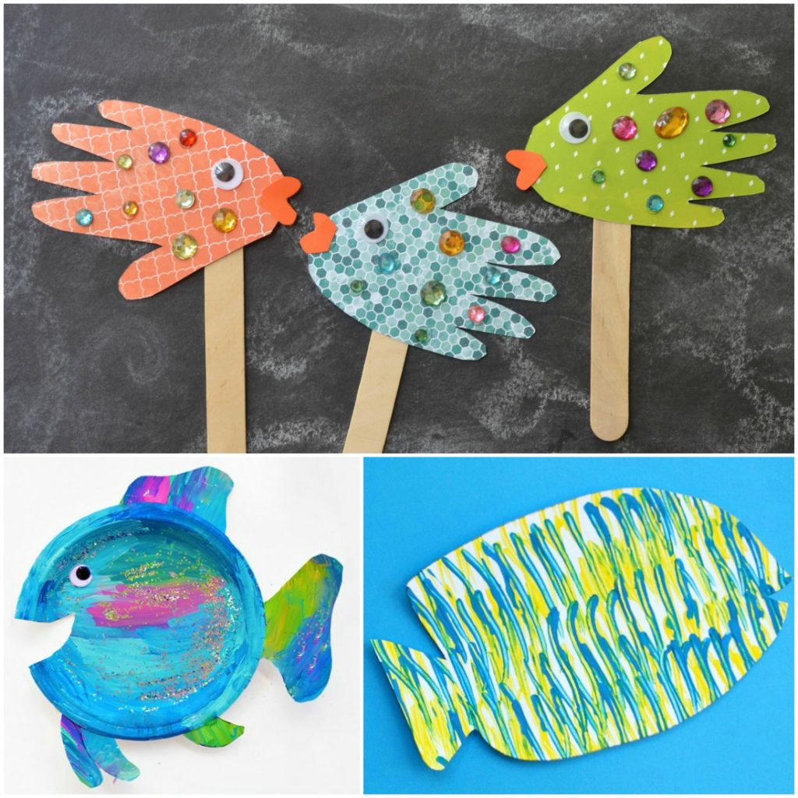
Why not try the Handprint Fish Puppets or the paper plate Rainbow fish or the Fork painted fish!

Music/PE – Listen to the song ‘Walk like an Egyptian’ by the Bangles. This song was released in 1986 so it is another song from the 80’s. You will find the song on YouTube. Once you have listened to it a few times try to do the dance to the song. I wonder if you will be able to walk like an ‘Egyptian’? You will find the song and dance moves on ‘Just Dance 2 Walk Like an Egyptian’ by Family Friendly Gaming on YouTube.

Just Dance 2 Walk Like an Egyptian – YouTube

RE - This week we are continuing with our story of Joseph. Last week we ended our story with Joseph being sold as a slave. I wonder what you will find out this week about the next stage of Joseph’s story. Watch the next part of the story on YouTube - 13 Pharaoh's Dream by Care Bear’s Bible Stories for Kids
Care Bear's Bible Stories For Kids
I’ve uploaded word search too to go along with this part of the story.
Finally check out our school website for a competition called Activate your curiosity. Some of you might want to try this out.

Remember all of the above information is just a guide to help you. Please don’t feel that you have to do everything on this list. Just pick the activities that you want to do or are of interest to you.
Mrs Kim McLaughlin xx

