Introduction to tens and units with exchange

Dear Primary 3 children and parents,
I hope that so far your tens and units activities have been going well and that the children are now confident in adding their tens and units when the total in the units house is 9 or less.
This week I am going to introduce the concept of addition with exchange to the children. To start this process it is important that the children understand the meaning of the word exchange. You might explain it as getting two toys the same for their birthday and having to bring one back to the shop to change it for something of the same value, that they would not have to pay any more or less for it and that the monetary amount would be the same once exchanged.
With that in mind, it is important to revisit a sum that totals 9 in the units house and ask the children what we would do if the number is larger than 9 in the hope that they would conclude that we need to exchange for a 10. For the purpose of introducing this I will attach various diagrams to show the step by step process that we would follow when completing addition with exchange sums using dienes tens and units materials firstly which will then be followed by 1p and 10p coins.

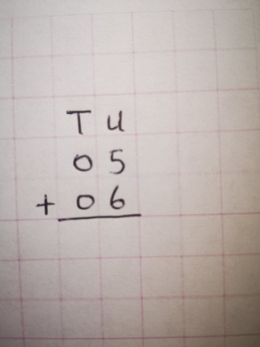 | The first sum that we are going to complete is 5+6. As before when writing our sum we always start in the units house (U) and then move to the Tens house (T) before completing our answers under the line which means ‘equals’.
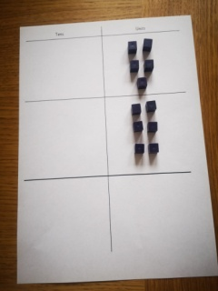 | To start get your tens and units card and place your 5 units in the top right hand box of the units house as in the diagram. Following that place your 6 units directly in the box underneath your 5 units.
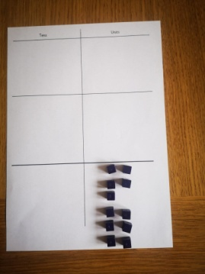 | When you have set out your units to make the sum then you can start to add the units together in twos.  Once you have added the units move them to the bottom right hand box on your card setting the units out in twos as you go.  Once your child has added these they will realise that there are 11 units altogether and they will realise that the number of units is greater than 9 and that they need to exchange.
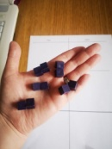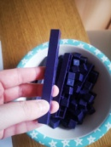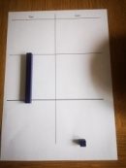 | The next step is for your child to count out 10 of the units that they have set on their card and then take a 10 rod to exchange. This 10 rod should then be placed in the middle left hand box of the tens house of their tens and units card.
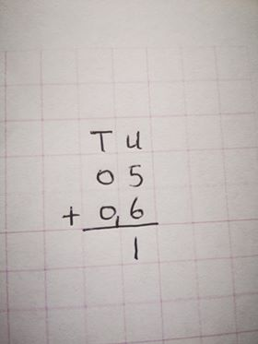 | Now we are ready to record our findings on our sum. The ten that has been exchanged must be written on the side of the tens house in a smaller format to remind us that it is not a two digit number. The one remaining unit is left in the units house as always.
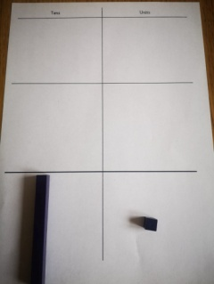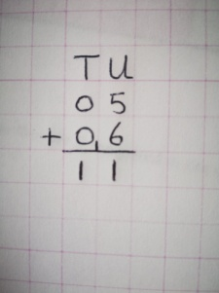 | We now move the tens rod to the bottom left hand box in the tens column/house and record our answer on our sum as follows.
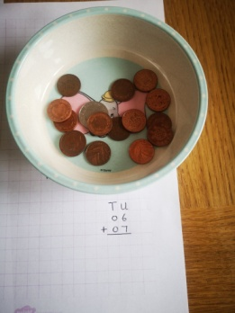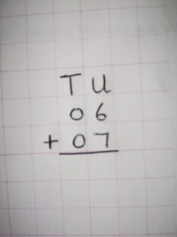 | If you are using coins then a similar process occurs. Let’s take the example of the sum  6 units +7 units (6+7).  Firstly write out the sum on your squared paper with T and U at the top as before and have your 1p coins and 10p coin ready in a pot.
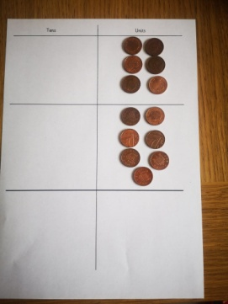 | Get your tens and units card and set out your 6 1p coins(units) in the top right hand box in the units column. Then set out your 7 1p coins (units) in the box directly underneath as so.

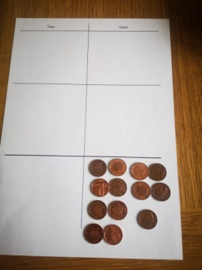 | When you have all your coins/units set out count them in twos and move them to the bottom right total box. When they are added your child should realise that they total 13 and they again need to exchange for a 10 p coin.
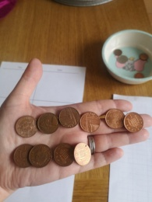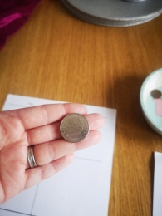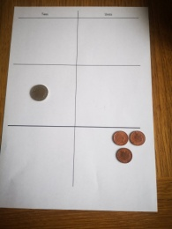 | Firstly ask your child to count out 10 1p coins individually and then exchange these for 1 10p coin and place in the middle left hand box in the tens column leaving the remaining 3 1p coins in the bottom right hand box of the units column.
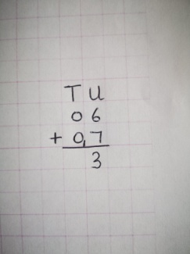 | Next we go back to our sum and once again we write our ten in a smaller format beside our bottom 0 in the tens column to remind us that it is not a two digit number.
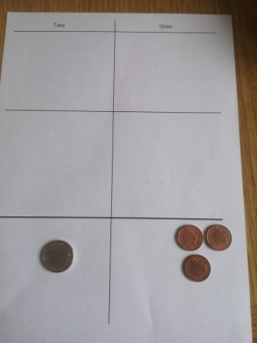 | We then move our 10p coin to the bottom left hand box of the tens column to help us realise that had 0 tens plus 0 tens plus the 1 ten that we exchanged.
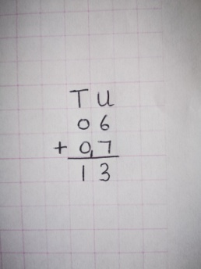 | Finally we record our tens finding on our sum and realise that our final answer is 1 Ten and 3 Units = 13.

I hope this has been explained in a way that will be easy to understand. Once you have completed this process, please feel free to attempt the correlating practice sums that I have set for this week. Thankyou.

