in





**Important Upcoming dates for your Diary**

**Last day of homeschool – Tuesday 30th June**

***Happy Birthday this month to:***

**Ariella**





**JUNE IN THE NURSERY**

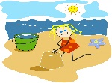****

Our theme this month is ‘Summer’ ‘Seaside’ and ‘Bugs’

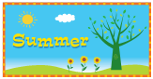

This month, we will be learning about summer, the seaside, holidays and bugs! To help us with our learning in this topic, please go for a walk with your child and talk about signs of summer (eg. flowers, grass-cutting, weather). Even go looking for bugs in your garden! Our Nursery trip will take the form of a Teddy Bears’ Picnic during the last week of term. Finally, we will also be talking with the children about starting P1, especially thinking about their new school and classroom and teachers!

In colour, we will be learning about the idea of dark and light shades in colours.

MC900360071[1]

MC900412556[1]The shapes we are learning about are diamonds (eg kite) and spheres (eg ball).

In number, we will be going over the numbers 1-10.



The concept we will be looking at is capacity - full and empty.

Our Personal Development focus this month is using kind words and ‘Having good manners.’ We will talk about saying, “Please! Thank you! Excuse me!”

Our independence target is to take responsibility for both ourselves and our personal safety; and also for our personal belongings.

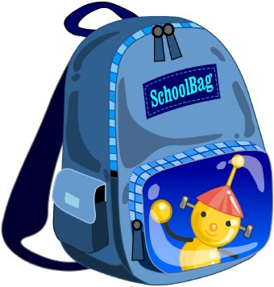 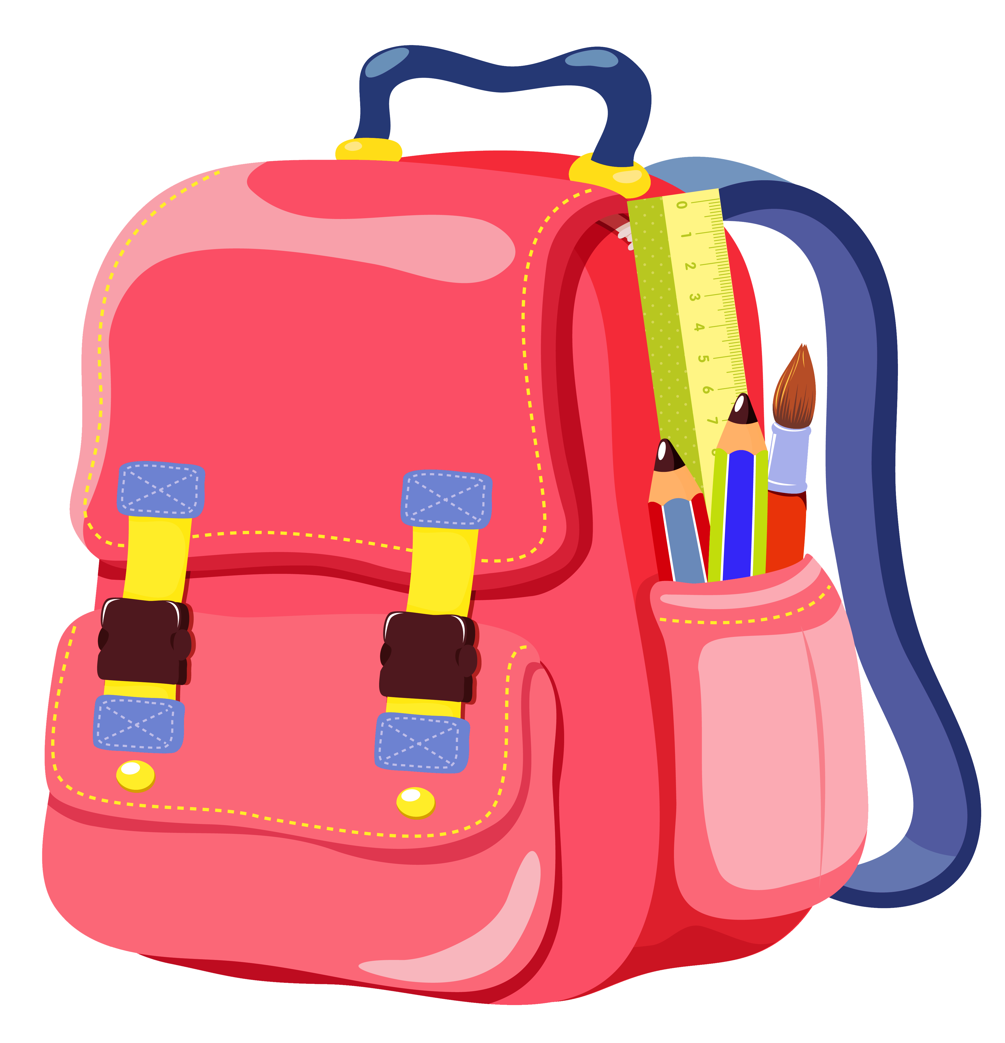

Our Physical Development focus is to develop our body strength and co-ordination, and to be able to manage the risks that we take (eg when climbing).

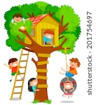

May I take this opportunity to thank you all for a wonderful (if slightly strange) year! You have all been so understanding, and the children have been an absolute delight! I wish you all a lovely summer, and best wishes both for P1 and for the years ahead!

**Can you name all the summer things in this picture?**

MC900361468[1]

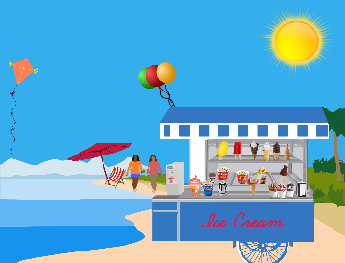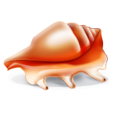MC900215681[1]MC900215681[1]MC900358169[1]MC900356453[1]MC900198642[1]MC900412548[1]MC900412556[1]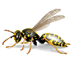MC900296211[1]MC900233594[1]MC900233594[1]MC900239391[1] 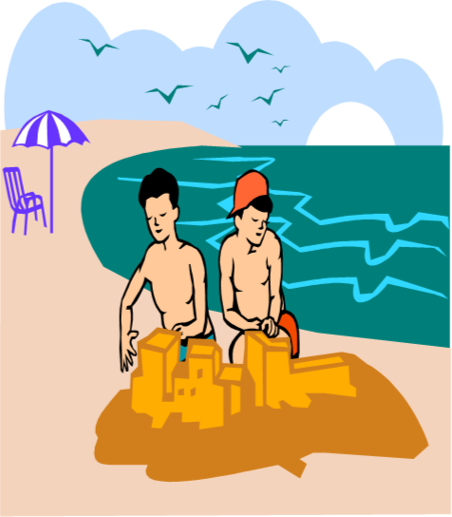

**1. What happens in summer? (it is hotter, trees get leaves)**

**2. Where do we go? (the park, the beach, on holidays)**

**3. What clothes do we wear? (shorts, sunhats, glasses)**

**4. What bugs come out in summer? (butterflies, bees)**

**5. What do we eat in summer? (ice-cream, picnics, barbeques)**

**6. What is your favourite thing to do on your holidays?**

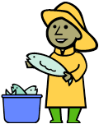One, two, three, four, five, Teddy bear, teddy bear, touch your nose,

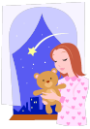Once I caught a fish alive. Teddy bear, teddy bear, touch your toes,

Six, seven, eight, nine, ten, Teddy bear, teddy bear, touch the ground,

Then I let it go again. Teddy bear, teddy bear, turn around.

Why did you let it go? Teddy bear, teddy bear, climb the stairs,

Because it bit my finger so! Teddy bear, teddy bear, say your prayers,

Which finger did it bite? Teddy bear, teddy bear, turn out the light,

This little finger on my right! Teddy bear, teddy bear, say goodnight!

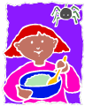

Incy Wincy spider climbed up the water spout; Little Miss Muffet

Down came the rain Sat on a tuffet,

And washed the spider out! Eating her curds and whey.

Out came the sunshine Along came a spider

And dried up all the rain; Who sat down beside her

So Incy Wincy spider climbed up the spout again! And frightened Miss Muffet away!



Round and round the garden, The sun has got his hat on,

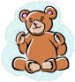Like a teddy bear. Hip, hip, hip, Hooray!

One step, two step, The sun has got his hat on,

Tickly under there! And he’s coming out to play!



When Goldilocks went Oh the bear went over the mountain

To the house of the bears, The bear went over the mountain

Oh what did her blue eyes see? The bear went over the mountain

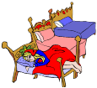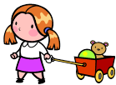A bowl that was big, To see what he could see.

A bowl that was small, But all that he could see,

A bowl that was tiny, But all that he could see

And that was all, Was the other side of the mountain,

And she counted them - 1, 2, 3!! The other side of the mountain,

(Repeat with: chairs… beds… bears…) The other side of the mountain

(Instead of ‘1, 2, 3’ on last verse, do 3 screams) Was all that he could see!



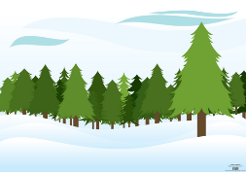If you go down to the woods today You are my sunshine,

You’re sure of a big surprise! My only sunshine.

If you go down to the woods today You make me happy

You’d better go in disguise! When skies are grey.

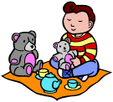For every bear that ever there was You’ll never know dear,

Will gather there for certain because How much I love you.

Today’s the day the teddy bears So please don’t take

Have their picnic! My sunshine away!