All About
African Zebras

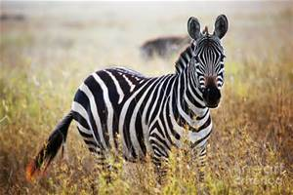
Contents:

The habitat of African
zebras Page 3

How are African zebras
suited to their habitat? Page 4

What do zebras eat
and drink? Page 6

Baby zebras Page 7

The Habitat of African Zebras

Most Zebras live in east and southern Africa.

- 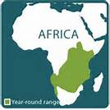

Zebras live here.

Zebras don’t live here.

They usually live in treeless grasslands and savanna woodlands whilst they stay away from deserts, rainforests, and wetlands.

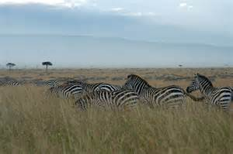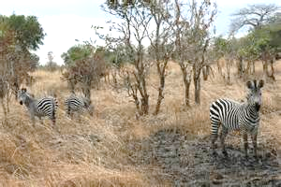

Zebras in treeless grasslands Zebras in Savannah woodlands
.
How are Zebras Suited to Their Habitat?

Zebras have excellent hearing and eyesight and are able to run 40 miles per hour - that’s faster than a car driving through Hermitage!
How do their legs protect them?
Zebras have long, thin legs which help them move quickly so they can escape from predators. They also have a powerful kick which can cause seriously hurt a predator such as a lion, hyena or African wild dog.

A zebra uses its powerful legs to kick a lioness.

Why do zebras have stripes?
Zebras are best known for their white and black stripes. Did you know that every zebras has a different pattern? This is just like the spots on a giraffe. Their stripes are a form of camouflage which makes it difficult to see the outline of the body or for a predator to spot a specific individual.

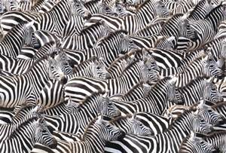
Zebra stripes make it difficult for predators to
see one individual zebra to attack

Clever Communication
Zebras communicate (talk) with each other with sounds and facial expressions. They make loud braying or barking sounds and soft snorting sounds.
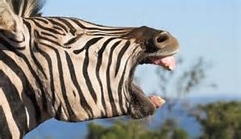
A zebra talking to other zebras
What do Zebras Eat and Drink?

Zebras mainly eat shrubs, herbs, twigs, leaves, several fallen fruit and bark but their really like eating green shoots such as grass.

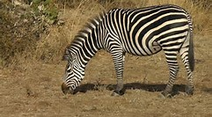
A zebra eats its favourite food.

Zebras typically feed in a zigzag manner. As they move they take quite a few leaves from a single plant. They spend most of their day eating but they also need to drink water regularly.

Did you know…?

Baby Zebras

Like horses, baby zebra are called foals. The young zebra is able to stand shortly after they are born and able to walk 15 minutes later and run after only an hour.

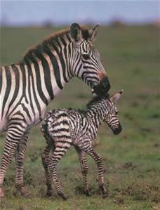
A mare (female zebra) with her foal
Zebras live in family groups of between 5 – 20 individuals which has one stallion (a male zebra), a few mares (female zebra) and their foals. These family groups stay together for many years. If one of the family group ever gets lost, the rest of the group will spend many days looking for it.
Did you know…?
Did you know that during the night, there is always one zebra standing on guard in case there are predators?

