All About
African Lions

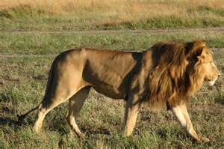

Contents:

The habitat of African
lions Page 3

How are African lions
suited to their habitat? Page 4

What do lions eat
and drink? Page 6

Baby lions Page 7

The Habitat of African Lions

African elephants live in the grasslands and woodlands in the African Savannah.

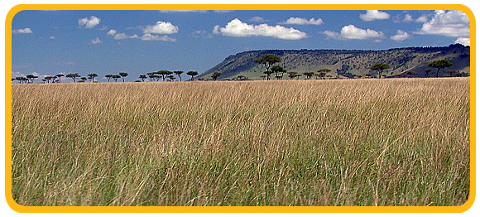
African Savannah Grasslands African Savannah woodlands

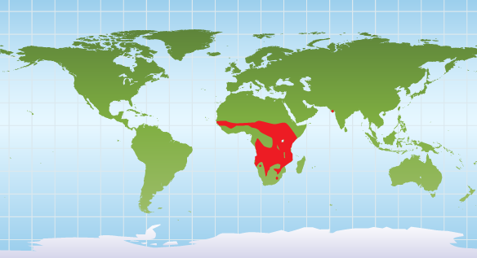

Lions live here.

Lions don’t live here.
How are Lions Suited to Their Habitat?

Thick Manes

Male (boy) lions have thick manes. These protect their neck when they fight.

Fighting lions

Roaring

Lions like to be with other animals so they live in groups of about 30 called prides. Pride members roar to each other so they know where they are.

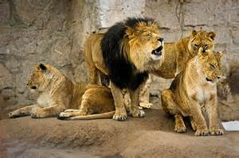
A lion roaring to its pride
Rough Tongue
A lion’s tongue is very rough. This helps it take off the skin of its prey so that it can eat the flesh underneath it. It is also used as a comb to groom themselves.

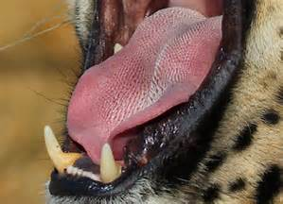
The tongue has tiny bumps on it
so it is rough.

Deadly Teeth
Lion’s teeth are well adapted for killing their prey and eating it. Their back teeth are called carnassals and they work like a pair of scissors.

Lions, like all cats, do not chew their food. Instead they swallow it in chunks.

Did you know lions only use one side of their mouth at a time? This is because they cannot move their jaw from side to side.

What do Lions
Eat and Drink?

Lions usually hunt at night. Their prey includes antelopes, buffaloes, zebras, young elephants, rhinos, hippos, wild hogs, crocodiles and giraffes. They also sometimes eat smaller prey like mice, birds, hares, lizards, and tortoises.

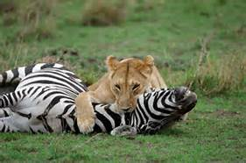

A lioness eats her prey

After a successful hunt, all the lions in the pride share the meal. However, the adult males always eat what they want first. After this, the lionesses (girl lions) eat. The cubs (baby lions) are the last to eat.

If it’s possible, lions will drink water every day. When they can’t, they can go for 4 -5 days without drinking because they get liquid from the stomach of their prey!

Fun fact!
Did you know that lions spend most of their day sleeping? They can be found lying on their backs with their feet up or taking a snooze up in a tree.

Baby Lions

Lionesses give birth to 2-3 cubs at a time. However, only one quarter of all cubs which are born manage to survive. This is because there are many predators such as hyenas and leopards, which can easily kill them. As well as this, many cubs are trampled on by larger animals such as buffaloes or drown in nearby rivers.

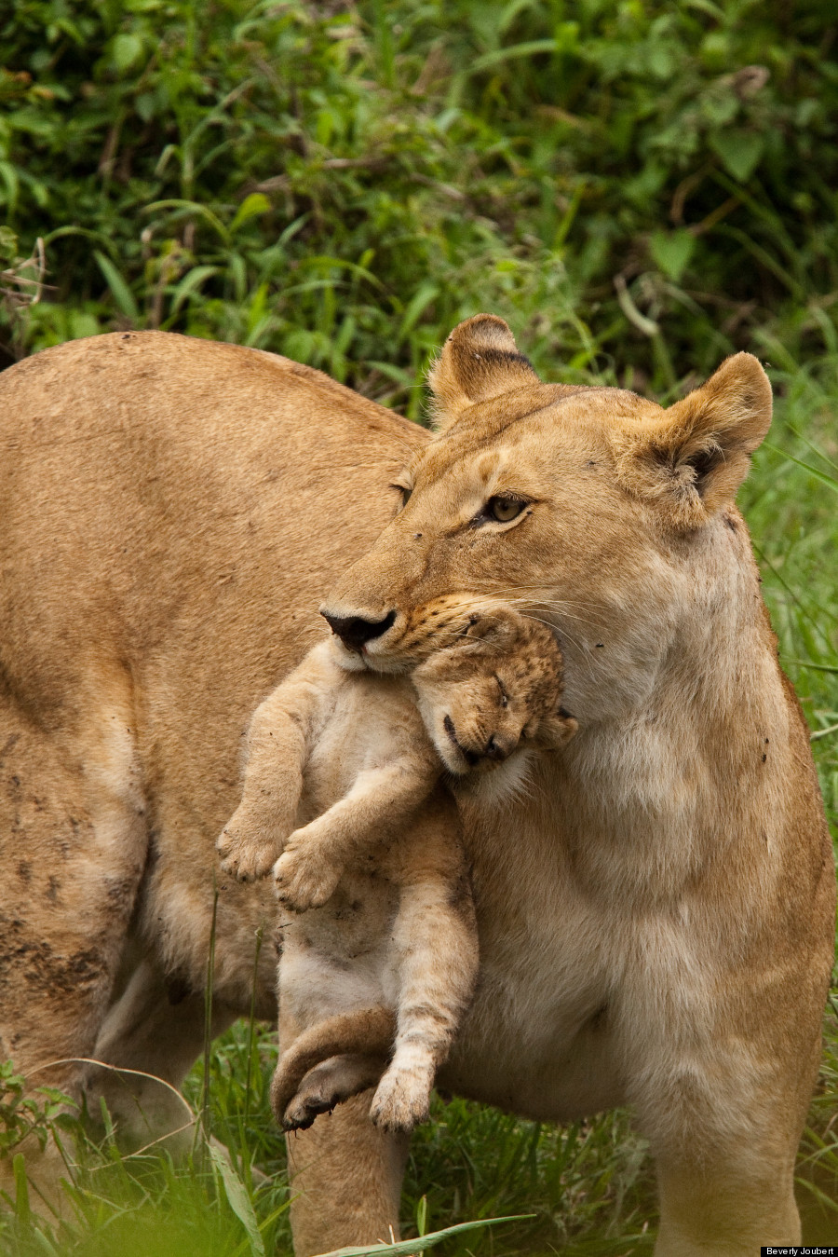
A lioness recues her cub from a river

Cubs love to play with each other. They can often look just like children who are playing tag.
Lion cubs playing

