P4/5M – Week 7 (Term 3)
Week beginning Monday, 1st June 2020
Hi P4/5M
How are you? I hope you are all keeping well. Today, is the first day of June! I always enjoy the month of June in the classroom, even though it is a very busy month in the school calendar. There is always great excitement when we start giving out your school books/work and removing art work from the wall displays to send home. The weather is normally nice and we get to play on the grass. We have our annual lunch time picnic and lots of you start guessing about who your new teacher will be in September. We have our Sports Day, school trips and then finally Summer Holidays arrive! All of these things I am going to miss this year. The 1st of June is a ‘busy day’ as it is Butterfly Education and Awareness Day and it is also Dinosaur Day!
Thank you to all of you who have been sending me emails. I love getting emails from you and seeing all your photographs. I love seeing all the great work you are doing at home. The weather has been beautiful recently so I hope you have been outside enjoying this glorious weather. Some of our lockdown restrictions have been relaxed so we can now travel further away from home. Have you done anything nice recently that you would like to share with me? If so, I would love to hear all about it. When I was at university, I had two very special friends called Paula and Muriel and to this day we have remained great friends. On Friday, Paula celebrated a very special ‘big birthday!’ Her family had organised for us to drive past her house with balloons and banners stuck to our cars. We had to meet at a set time and then travel in convoy to Paula’s house, where her husband and children had her outside in the garden. She got such a lovely surprise when we all drove past one after the other. At the end Muriel and I went back to Paula’s house and drank tea in her garden. We remembered to keep 2 metres away from each other. It was so lovely to be able to see my dear friend on her birthday and it will be a memory we will cherish forever.
Below is a guide for you to use this week. Remember that it is only a guide, and I wouldn’t expect you to cover everything on this list. Just do as much as you can.

Weekly Fact – Revise Parts of Speech. Parts of speech include nouns, adjectives, verbs, adverbs, pronouns, prepositions and conjunction. This week we are going to revise adjectives, verbs, adverbs and pronouns.
Adjectives – describe a noun. For example : The red car. Car is the noun and the word red is the adjective describing the car.
Verbs – are action words. For example – run, hop, jump, skip etc.
Adverbs – describe how a verb is done. Most adverbs end in ‘ly’. For example : the boy shouted loudly. The verb is shouted and the adverb describing how it was done is loudly.
Pronouns – is a word used to replace a noun. We use pronouns so that we don’t need to keep repeating the same noun. For example: We took the car to the garage because the car needed fixing. When using pronouns, we would say – We took the car to the garage because it needed fixing. The pronoun is ‘it’.

Literacy
Vocabulary Genie – Word of the Day. Our word this week is ‘release’ – I’ve uploaded a worksheet for this task so you can either print it off or write the word into your Literacy Classwork book.
Also for Literacy, I’ve uploaded a comprehension called ‘Dinosaur Dream’ and a reading activity called Dinosaur Defences to tie in with Dinosaur Day. There is also a dinosaur book marker to download. For grammar, I also uploaded some sheets on adjectives, verbs, adverbs and pronouns. Remember, you don’t have to do all the sheets. Just pick a few. Also, remember to continue with your reading, spellings and New Wave English.
Numeracy
Mental maths – I’ve uploaded more mental maths sheets to use if you have finished New Wave Maths.
Number work – this week I’ve uploaded some multiplication word problem solving questions and multiplication using grid method. You will find 4 documents
Topic maths - Measure (watch PowerPoint on Measure)

TWAU – NEW TOPIC – Out of Africa. (Please see separate note detailing activities for each week). We are on week 2. This week we will be learning about African animals.

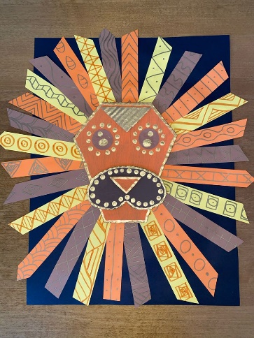
Being Creative – Describing someone using adjectives

Art – making African animal faces using card and paper.
(See picture at the end of letter)

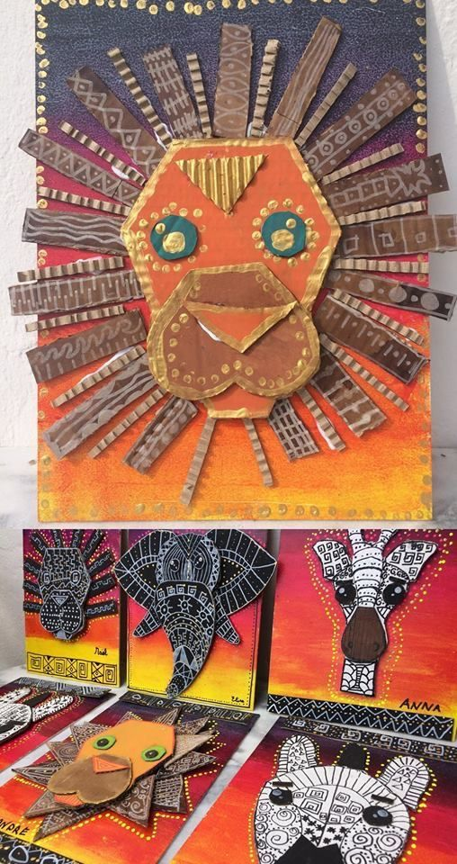
Art –

Music
I remember how much you all enjoyed playing the percussion instruments in class. This week why don’t you try creating your own xylophone using glasses and water. There are some videos below, one which explains how to do this (Make Music with Water Glasses), and two which show examples of tunes you can play - one quite straightforward (Twinkle, Twinkle) and the other very complex (Pirates of the Caribbean!). I do not expect you to recreate this but it is just to show you an example of what you could do!
Most importantly, I want this to be a fun activity, get members of your family involved in helping/playing and just enjoy making music with what you have in the house! Ben, Harry and I tried this but we soon discovered that we weren’t very musical! I’m sure you will be much better than us.

https://www.youtube.com/watch?v=oGj1rZEu1y8
https://www.youtube.com/watch?v=gUIA5vkcK60
https://www.youtube.com/watch?v=muMutEWeS6c

RE - Joseph. This week we are going to be finding out about Joseph. I remember how much you enjoyed the story of Moses so I hope you enjoy the story of Joseph too.
I’ve uploaded a story sheet about Joseph, a colouring sheet and a worksheet. There is also a YouTube video to watch. It is called - Joseph and His Coat of Many Colors! -100 Bible Stories

P.E. – Get outside and have fun!

Remember all of the above information is just a guide to help you. Please don’t feel that you have to do everything on this list. Just pick the activities that you want to do or are of interest to you.
Mrs Kim McLaughlin xx
